Name: _____________________________ Date: _______________

Computer Science II Mr. Wuest

Unit 3: Assignment #1

1) Use the following criteria below to create a face.

**Overall face circle**: 100 pixel diameter, starting position is (10, 30)

**Eyes**: blue circles, 20 pixel diameter; circles are 40 pixels apart, 20 pixels to the right and 30 pixels down from the starting position of the overall face circle.

**Mouth**: red line, starting position is 30 pixels to the right and 70 pixels down from the starting position. The mouth is 40 pixels long.

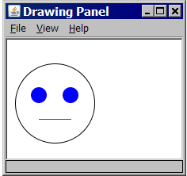

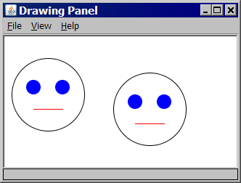

The second face starts at (150, 50).

2) The window is 200 pixels wide and 200 pixels tall. There are 20 pixels between each of the four squares, and the squares are concentric (their centers are at the same point). The inner most square has a length of 40. You must use a for loop to create this image.

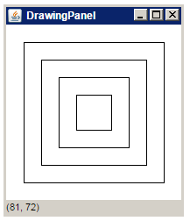

3) Consider the output at right. The first stair's top-left corner is at position (5, 5). The first stair is 10 x 10 pixels in size. Each stair is 10 pixels wider than the one above it.

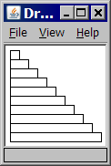

4) Using a window size of 400 by 400 create the following image below. (Remember, there is extra information in the Graphics PowerPoint that will help you for this question.)

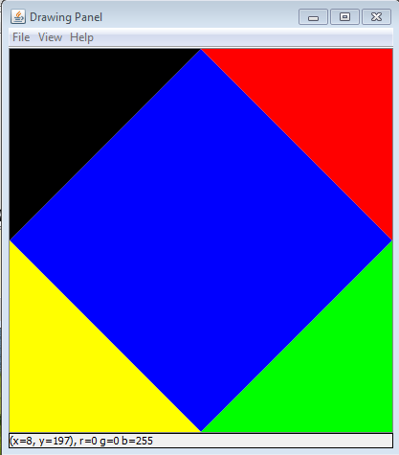

5) Create the following image below using a DrawingPanel of size 400 by 400. The image should be created in a method called constructionCar which returns nothing and has no parameters. Each circle has a width of 100 pixels, is 50 pixels from the edge of the DrawingPanel, and the top of the circle is 150 pixels from the bottom of the DrawingPanel.

(You can assume the blue body of the car is a square)

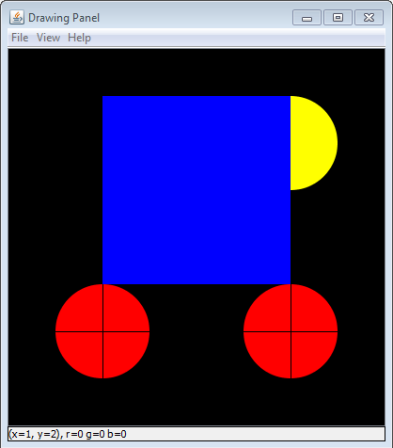

**Extra Credit Question:**

